CODING ASSESSMENT PYTHON(PANDAS) :
29-07-2025
1.CREATED A ‘your_data.csv’ FILE AND USED IT.
id,name,age,city
1,Lokanya,28,New York
2,Abdul Basith,28,Los Angeles
3,Gayathri ,45,Chicago
4,Ajay,29,Houston
5,Sai Vignesh,32,Phoenix

2.Handling missing values
import pandas as pd
# Load your data
df = pd.read_csv('your_data.csv')
# Check for missing values
print(df.isnull().sum())
# Drop rows with missing values
df_cleaned = df.dropna()
# Alternatively, fill missing values
df_filled = df.fillna(value={'column_name': 'default_value'})

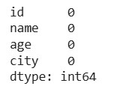

3.Removing duplicates
# Remove duplicate rows
df_no_duplicates = df_cleaned.drop_duplicates()

4.Data type conversion
import pandas as pd
# Load your data
df = pd.read_csv('your_data.csv')
# Check the DataFrame
print("Original DataFrame:")
print(df)
# Convert the 'age' column to integer type
df['age'] = df['age'].astype(int)
# Check the DataFrame after conversion
print("\nDataFrame after converting 'age' to int:")
print(df)

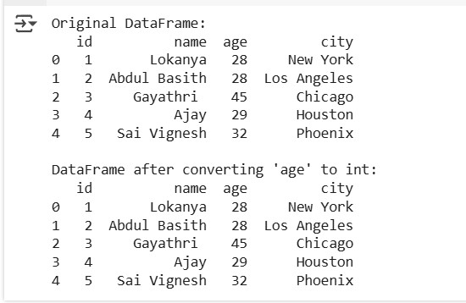
5. Inner Join
An inner join returns only the rows with matching values in both DataFrames.
import pandas as pd
# Sample DataFrames
data1 = {'key': ['K0', 'K1', 'K2'], 'value1': ['A', 'B', 'C']}
data2 = {'key': ['K1', 'K2', 'K3'], 'value2': ['D', 'E', 'F']}
df1 = pd.DataFrame(data1)
df2 = pd.DataFrame(data2)
# Inner Join
result_inner = pd.merge(df1, df2, on='key', how='inner')
print("Inner Join Result:")
print(result_inner)
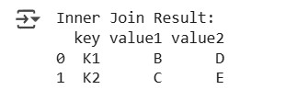

6. Left Join
A left join returns all rows from the left DataFrame and the matched rows from the right DataFrame.
# Left Join
result_left = pd.merge(df1, df2, on='key', how='left')
print("\nLeft Join Result:")
print(result_left)
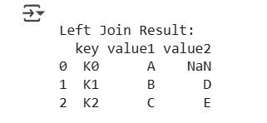

7. Right Join
A right join returns all rows from the right DataFrame and the matched rows from the left DataFrame.
# Right Join
result_right = pd.merge(df1, df2, on='key', how='right')
print("\nRight Join Result:")
print(result_right)
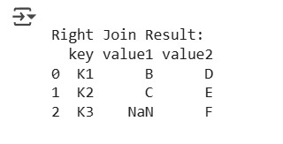

8. Outer Join
An outer join returns all rows from both DataFrames, filling in NaNs for missing matches.
# Outer Join
result_outer = pd.merge(df1, df2, on='key', how='outer')
print("\nOuter Join Result:")
print(result_outer)
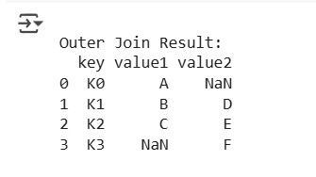

9. Using .join() Method
The .join() method is useful for joining DataFrames based on their indices.
# Sample DataFrames with indices
df1.set_index('key', inplace=True)
df2.set_index('key', inplace=True)
# Join using .join()
result_join = df1.join(df2, how='inner', lsuffix='_left', rsuffix='_right')
print("\nJoin Result using .join():")
print(result_join)
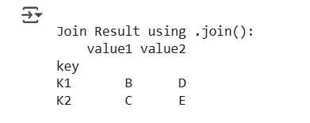

10. Concatenating DataFrames
You can also concatenate DataFrames vertically or horizontally.
# Concatenating DataFrames
result_concat = pd.concat([df1, df2], axis=0, ignore_index=True)
print("\nConcatenated DataFrame:")
print(result_concat)
